Stage 4 – "C'mon in boys, the water is fine."
COURSE DESIGNER: Ryan Christenson
SCORING: Comstock 22 rounds.
TARGETS: 10 cardboard targets, 2 steel targets
SCORED HITS: 2 Best hits per carboard will be scored.

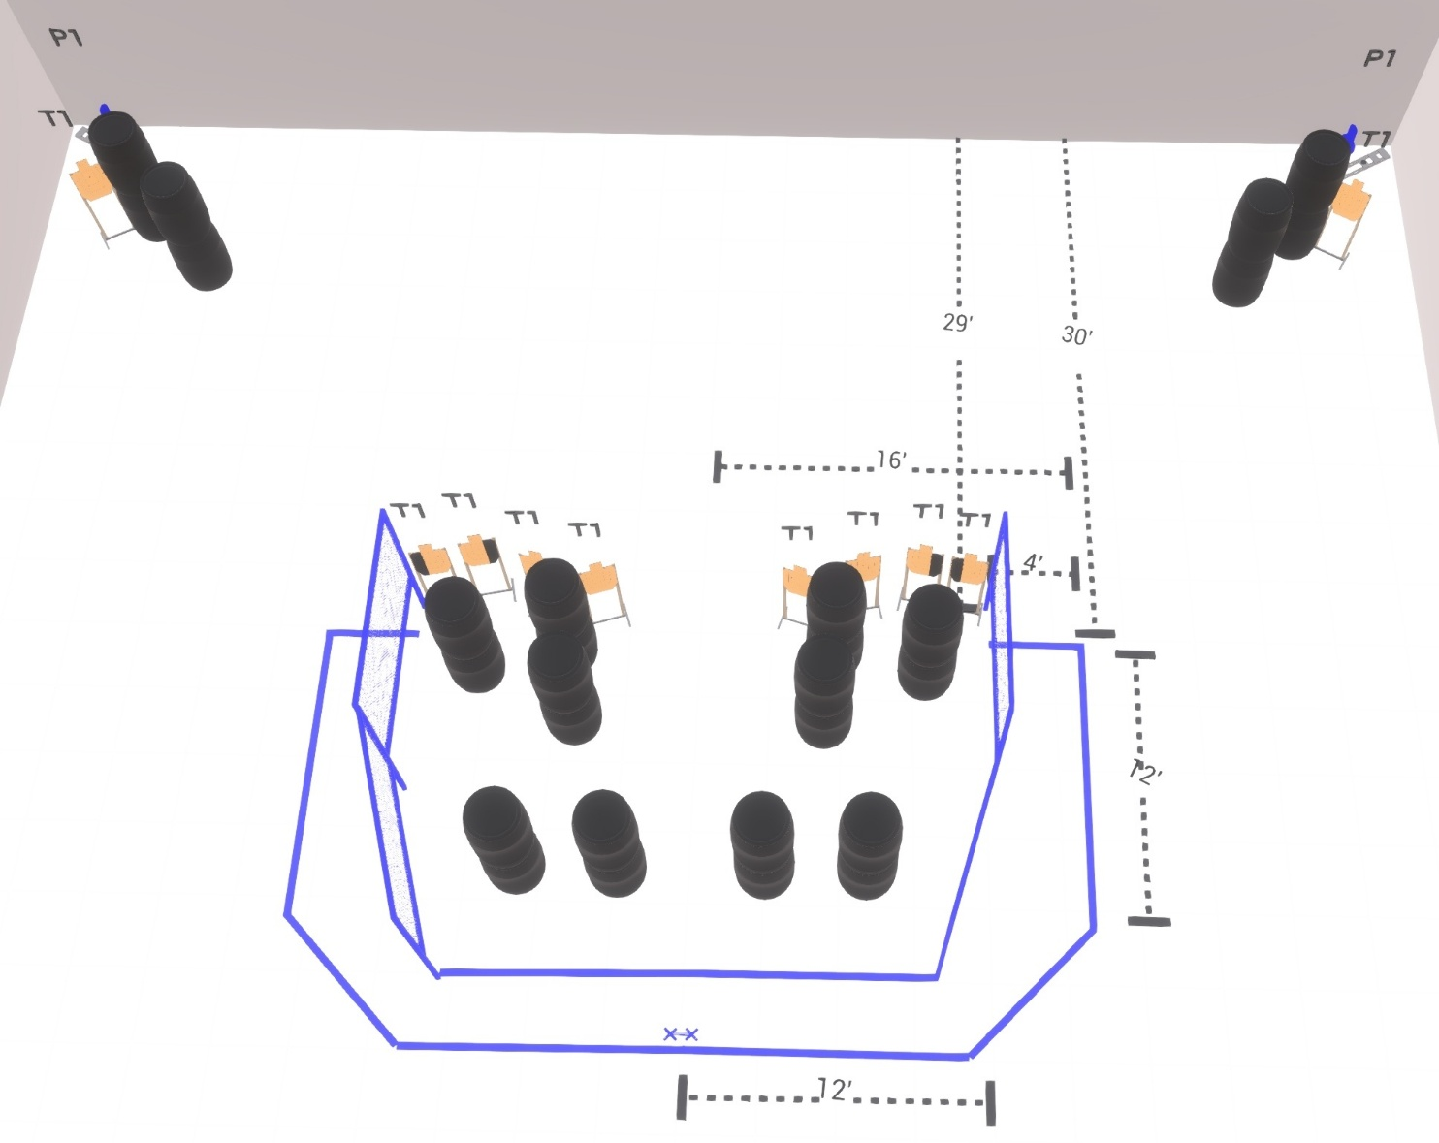

Written Stage Briefing:

Stage 4 – "C'mon in boys, the water is fine.” - is a 22 round, 110 point, Comstock Course. There are 10 cardboard targets and 2 steel targets.

Starting with Both feet on the Shooting Sports Innovations Xs.
Handgun is loaded and holstered, wrists below belt.
PCC is loaded held in both hands, stock on belt.

On the audible start signal, engage targets from within the shooting area.

USPSA / NROI Range Commands:
- Make Ready
- Are you ready?
- Standby
- If finished, unload and show clear
- If clear, hammer down and holster (Handgun)
If clear, hammer down and flag (PCC)
If clear, cylinder closed and holster (Revolver)
- Range is clear

Setup Notes:
4 Single Wall Stands
4 Full Walls
10 Target stands / 20 target sticks
2 Small Poppers
28+ Barrels



